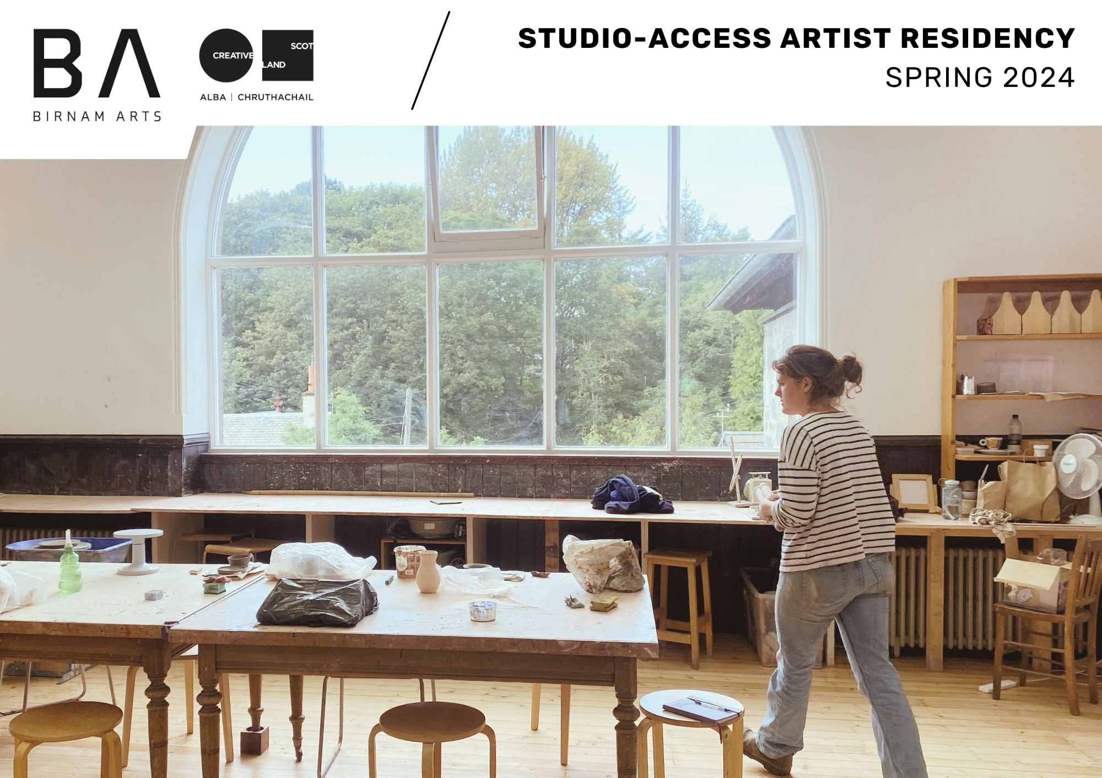
Following the success of our 2021-23 Artist-in-Residence (AiR) opportunities, and with thanks to further funding from Creative Scotland, we are delighted to offer our Studio-Access Artist Residency for Spring 2024.

The Spring 2024 AiR opportunity provides the following access and support:
- Artist Fee of £500
- 10 studio sessions: morning, afternoon or evenings, to be used before Sunday 30th June 2024
- Access to the Visual Arts and/or Dance & Drama Studios
- 3 Mentoring Sessions
- No expectation of exhibition or public sharing of work.
- Option to deliver Artist Talk for additional fee, if appropriate

This AiR opportunity aims to provide access to a dedicated artistic space, with the option of evening and weekend access, recognising the challenges of balancing paid work and/or family/caring responsibilities whilst developing a growing artistic practice. We envisage this will be most suitable to an artist or maker who is looking to re-establish a routine of focus to their work. We are particularly interested in applications from people who have taken a break from their practice due to raising children, caring for another person/people and supporting their family. The Birnam Arts programme promotes equality, diversity and inclusion in all areas. We actively encourage applications from artists from a minority ethnic background, from LGBTQ+ communities, artists living with a disability, neurodivergent artists, artists balancing their work with care responsibilities, and artists living and working in areas of multi-deprivation. We are also committed to addressing environmental and climate change issue and we welcome applications that explore this subject matter.

In order to help us grow this programme and to secure future funding, we ask that the awarded artist/maker provides us with feedback on their time with us.

Eligibility
You must be a Scottish based artist or maker working in the visual and/or applied arts sector.

Given this is not a residential opportunity and Birnam Arts is looking to support an artist or maker to dedicate routine access to the studio and practice development, applications from Perthshire based artists will be prioritised. However, if you are able to demonstrate clearly how you would intend to access the space through sourcing local accommodation, we would welcome your application.

Please ensure all sections are completed and returned to us at visualarts@birnamarts.com by midnight on Sunday 7th April 2024. Incomplete or late applications will not be considered.

FAQ’s
Do I have to be Scottish?
No, you can be any nationality, but you must be based in Scotland and have a UK bank account.
Do you provide accommodation?
No, this as a studio-access only opportunity. Please visit dunkeldandbirnam.org.uk for recommendations of local hospitality and accommodation providers.
Are you a wheelchair accessible venue?
Yes, we have dedicated accessible parking and facilities including toilets (on both floors), low ramps between areas, and a lift.
Can I apply in collaboration with another artist or maker?
Yes, but please note that the support and access remains the same regardless of how many people are involved with your project.
Will you provide letters of support if I want to apply for additional funding?
Yes, we can support you with this. A budget of what we offer in-kind would also be available.
Is it possible to have an exhibition off the back of this residency?
Yes, there is potential for this but is not expected of you.

Studio-Access Artist Residency 2024
These boxes will expand to accommodate your word count.
Name
Address
Current Level
e.g., emerging artist
Website/Portfolio URL
Social Media Links
Artist Statement
(150 words)

Project Proposal
(700 words)

How will the residency benefit you as an artist and your practice?
(400 words)

Indicate your flexibility or days and times of preferred access.
Access to the building is possible 7 days per week, however all studio visits must be scheduled in advance, and must be able accommodate our programme of workshops and classes, which also use the studio spaces. Please indicate your access time preferences here.

All submissions should be sent to visualarts@birnamarts.com by midnight on Sunday 7th April 2024. Please note that late submissions will not be accepted.
This document is available in large print. Please request by email ______ or phone 01350 727 674.

