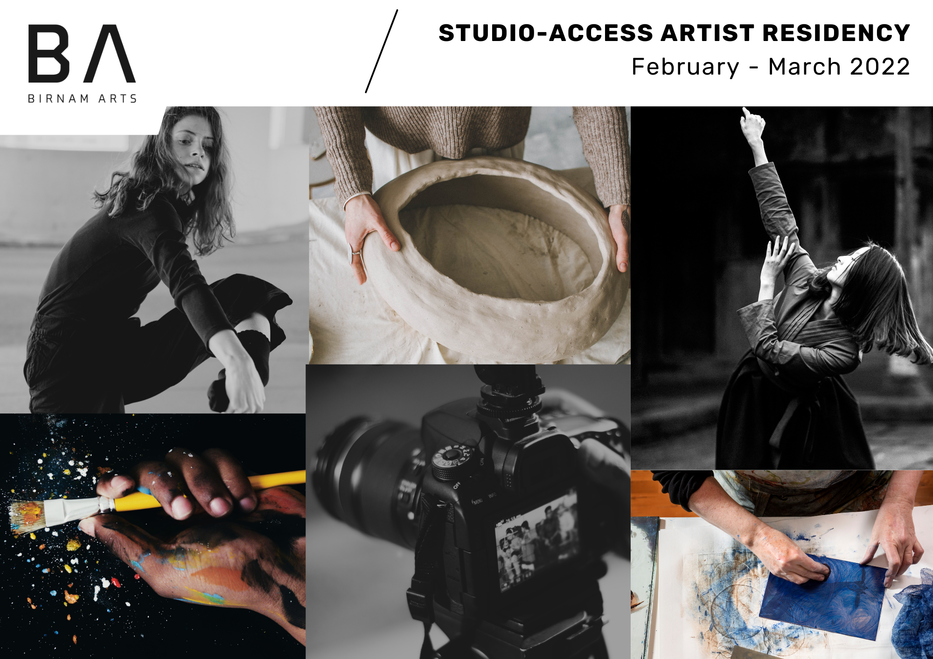

Please ensure all sections are completed as incomplete applications may not be considered. These boxes will expand to accommodate your word count.
Name
Address
Current Level
e.g., emerging artist
Website/Portfolio URL
Social Media Links
Artist Statement
(150 words)

Project Proposal
(500 words)

How will the residency benefit you as an artist and your practice?
(400 words)

Indicate your flexibility or days and times of preferred access.  Access to the building is open 9am to 5pm, Mondays to Fridays.  Saturday and Sunday hours are 10am to 4pm. Some evening access will be possible, please indicate your preferences here. | Monday –  Tuesday –  Wednesday –  Thursday –  Friday –  Saturday –  Sunday –
All submissions should be sent to kate@birnamarts.com by 5pm on 5th January 2022. Please note that late submissions will not be accepted.
This document is available in large print. Please request by email kate@birnamarts.com or phone 01350 727 674.

